Press Release

Method Park is now TISAX® certified
IT service provider complies with the high security requirements of the automotive industry
Method Park has been certified with the TISAX® label for information with very high security requirements since February 2021. In record time, the IT department had made the company fit for the strict security standards of its automotive customers.
Erlangen, April, 28, 2021 - Method Park has successfully certified according to TISAX® (Trusted Information Security Assessment Exchange). In a four-day assessment according to Level 3, TÜV Süd certified that the four subsidiaries of the corporate group meet the desired security standard and thus the handling of information with very high protection needs. In the audit according to the requirements catalog of the German Association of the Automotive Industry (Verband der Automobilindustrie e.V - VDA), Method Park was able to demonstrate a very high level of protection for information security. In addition to the carefully maintained documentation of IT processes, Method Park presented a well-designed network and virtual training concept.

Reliable partner
The successful certification according to TISAX® is an important milestone for the Erlangen-based software and systems company Method Park in the consulting and support of its customers from the international automotive industry. Information security has been an important competitive factor in this industry for many years. The protection of sensitive and confidential data in the exchange between manufacturer and service provider has obtained more importance since more and more project members work from home, among others, due to the Covid-19 pandemic.
"The successful completion of the TISAX® assessment emphasizes our commitment to the responsible handling of our customers' security-sensitive information," emphasizes Prof. Dr. Bernd Hindel, CEO of the Method Park Group. With the TISAX® certification, Method Park has proven to be a highly reliable partner in IT security and strengthened its market access to the automotive industry.

Certification in just nine months
Method Park completed the preparation and execution of the assessment in record time. In just nine months and with the support of T-Systems Multimedia Solutions GmbH, the Method Park IT department succeeded in making the workforce and infrastructure fit for information security, so the four companies Method Park Holding AG, Method Park Software AG, Method Park Engineering GmbH, and Method Park Consulting GmbH passed the TISAX® audit in the very first evaluation cycle. Steffen Schreiner, Head of IT at Method Park, emphasizes: "This was only possible thanks to the dedicated and constructive cooperation of all involved!"

IT security strategy
For Method Park, TISAX® is one aspect of its holistic IT security strategy. Following the successful DIN ISO 9001 and DIN EN ISO 13485 certifications, the company can now present its third certification with the TISAX® label.
Number of characters (space characters included): 2,983
About TISAX®
TISAX® (Trusted Information Security Assessment Exchange) is a standard for information security defined by the automotive industry. Manufacturers and suppliers in the German automotive industry have required many business partners to have an existing TISAX® certification since 2017.
The member companies of the German Association of the Automotive Industry (Verband der Automobilindustrie e.V.) have created a catalog of requirements (VDA ISA) derived from the international industry standard ISO/IEC 27001 and adapted to the requirements of the automotive industry.
The operator of TISAX is the ENX Association, which has been entrusted with its implementation by the VDA as a neutral body. International auditors are accredited on behalf of ENX to perform the audit.
About Method Park
Method Park specializes in complex product engineering in the environments of the automotive, medical, and aerospace industries. Method Park's portfolio includes consulting and engineering services, a comprehensive training program, and the process management tool "Stages".
Method Park was founded in 2001. On a worldwide basis, the company has coached its customers on process optimization, compliance to industry-specific standards and legal regulations. It has also consulted on the management of projects, products, and quality assurance.
Method Park offers a practice-based training program on all current topics of software and systems engineering. Method Park offers training at its locations in Germany and other European countries, the US and Asia.
With "Stages", Method Park offers an individually customizable process management tool which supports its users on the definition, communication and application of complex processes.
The company group has locations in Erlangen, Munich, Stuttgart, Frankfurt on the Main, Hamburg, and Berlin as well as in Detroit, Miami, and Pittsburgh in the US and Shanghai in China. Today, about 230 employees work for Method Park. In 2020, Method Park generated an operative turnover of about 25 million euros.
For further information please contact:
Dr. Christina Ohde-Benna, PR-Assistant
Method Park Holding AG, Wetterkreuz 19a, 91058 Erlangen, Germany
Christina.Ohde-Benna@methodpark.de www.methodpark.com

Available pictures:
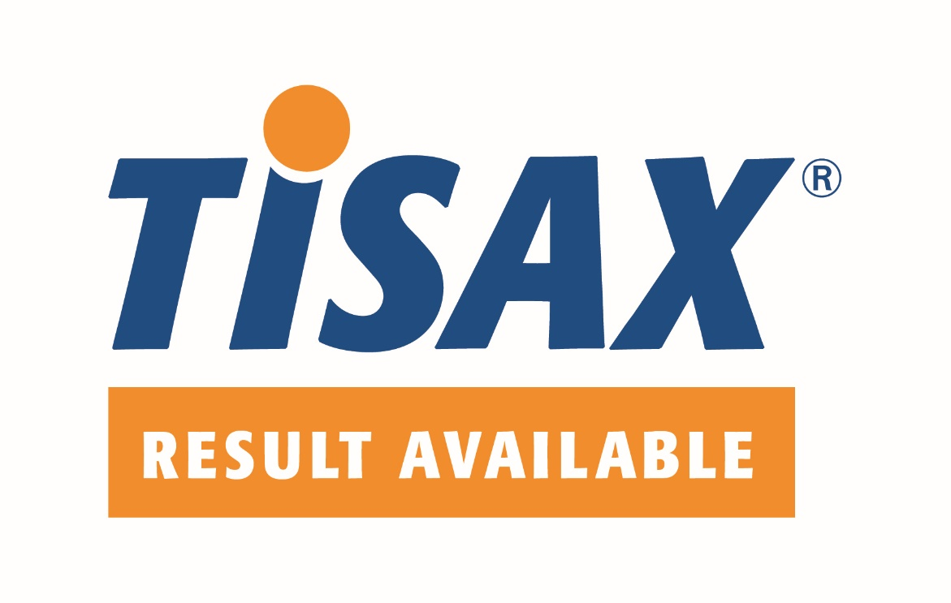
Caption: Method Park is now TISAX® certified.

