Press Release

Method Park opens new branch office
Expansion of German branch network with Berlin
Customers in the north-eastern German region now benefit locally from Method Park’s consulting portfolio. The Berlin branch will continuously strengthen its local training program.
Erlangen, February 09, 2021 - Method Park opens its tenth office in Berlin to advise and support customers even faster and more locally. Method Park training courses have already been taking place there since 2019.

Focus industries
At the Berlin location, the Method Park team focuses on safety-critical software development in the automotive and medical device industries in the first place and will then address the aerospace, transportation, and railway industries in the medium term.

Focus topics
Accordingly, the consulting services focus on the industry-specific Automotive SPICE® quality standard and the ISO 26262 standard requirements on functional safety. From mid-February, the Berlin team will advise and support customers in this area and gradually provide more training courses.

Process experts
Method Park consultants offer their process know-how, expertise in norms and standards requirements, and a wide range of development methods from numerous international projects. Customers demand profound process consulting in standard-compliant software and systems development, especially in safety-critical and standardized environments like automotive or medical devices. Agile development methods play an increasingly important role in these industries. Method Park now meets the growing demand for these topics from its Berlin branch in the Regus Center near the Federal Chancellery.

Process management tools
For holistic process consulting, the Berlin consultants rely on the process management tool Stages, Method Park’s in-house development. Stages supports its users in the definition, communication, and use of complex processes. Customers from the northeast German region now receive on-site consulting on this Method Park product.

Engineering services
Method Park will also offer engineering services in addition to consulting in the medium term in Berlin. Method Park engineers will then support their customers hands-on with developing software components, the practical application of development methods, or the creation and maintenance of toolchains.

Events
Method Park will host events for customers and partners at the new branch office, e.g., meetings of the ASQF Automotive Berlin/Brandenburg expert group, chaired by location manager Heiko Zastrau or lecture evenings as part of the Method Park Talk in the Park event series, as soon as the situation allows it.

Location address
The new branch office has the following address:
Method Park Consulting GmbH
Rahel-Hirsch-Strasse 10, 3rd floor
10557 Berlin
Automotive SPICE® expert Heiko Zastrau is the Berlin branch manager.
Number of characters (space characters included): 2.649
About Method Park
Method Park specializes in complex product engineering in the environments of the automotive, medical, and aerospace industries. Method Park’s portfolio includes consulting and engineering services, a comprehensive training program, and the process management tool “Stages”.
Method Park was founded in 2001. The company has coached its customers on process optimization worldwide, compliance with industry-specific standards and legal regulations. It has also consulted on managing projects, products, and quality assurance.
Method Park offers a practice-based training program on all current topics of software and systems engineering. Method Park offers training at its locations in Germany and other European countries, the US and Asia.
With “Stages”, Method Park offers an individually customizable process management tool that supports its users on the definition, communication, and use of complex processes.
The company group has locations in Erlangen, Frankfurt on the Main, Hamburg, Munich, Stuttgart, and Berlin and Detroit, Miami and Pittsburgh in the US, and Shanghai in China. Today, about 230 employees work for Method Park. In 2020, Method Park generated an operative turnover of about 25 million euros.
For more information, please contact:
Dr. Christina Ohde-Benna, PR-Assistant
Method Park Holding AG, Wetterkreuz 19a, 91058 Erlangen, Germany
Christina.Ohde-Benna@methodpark.de www.methodpark.com
Available pictures:
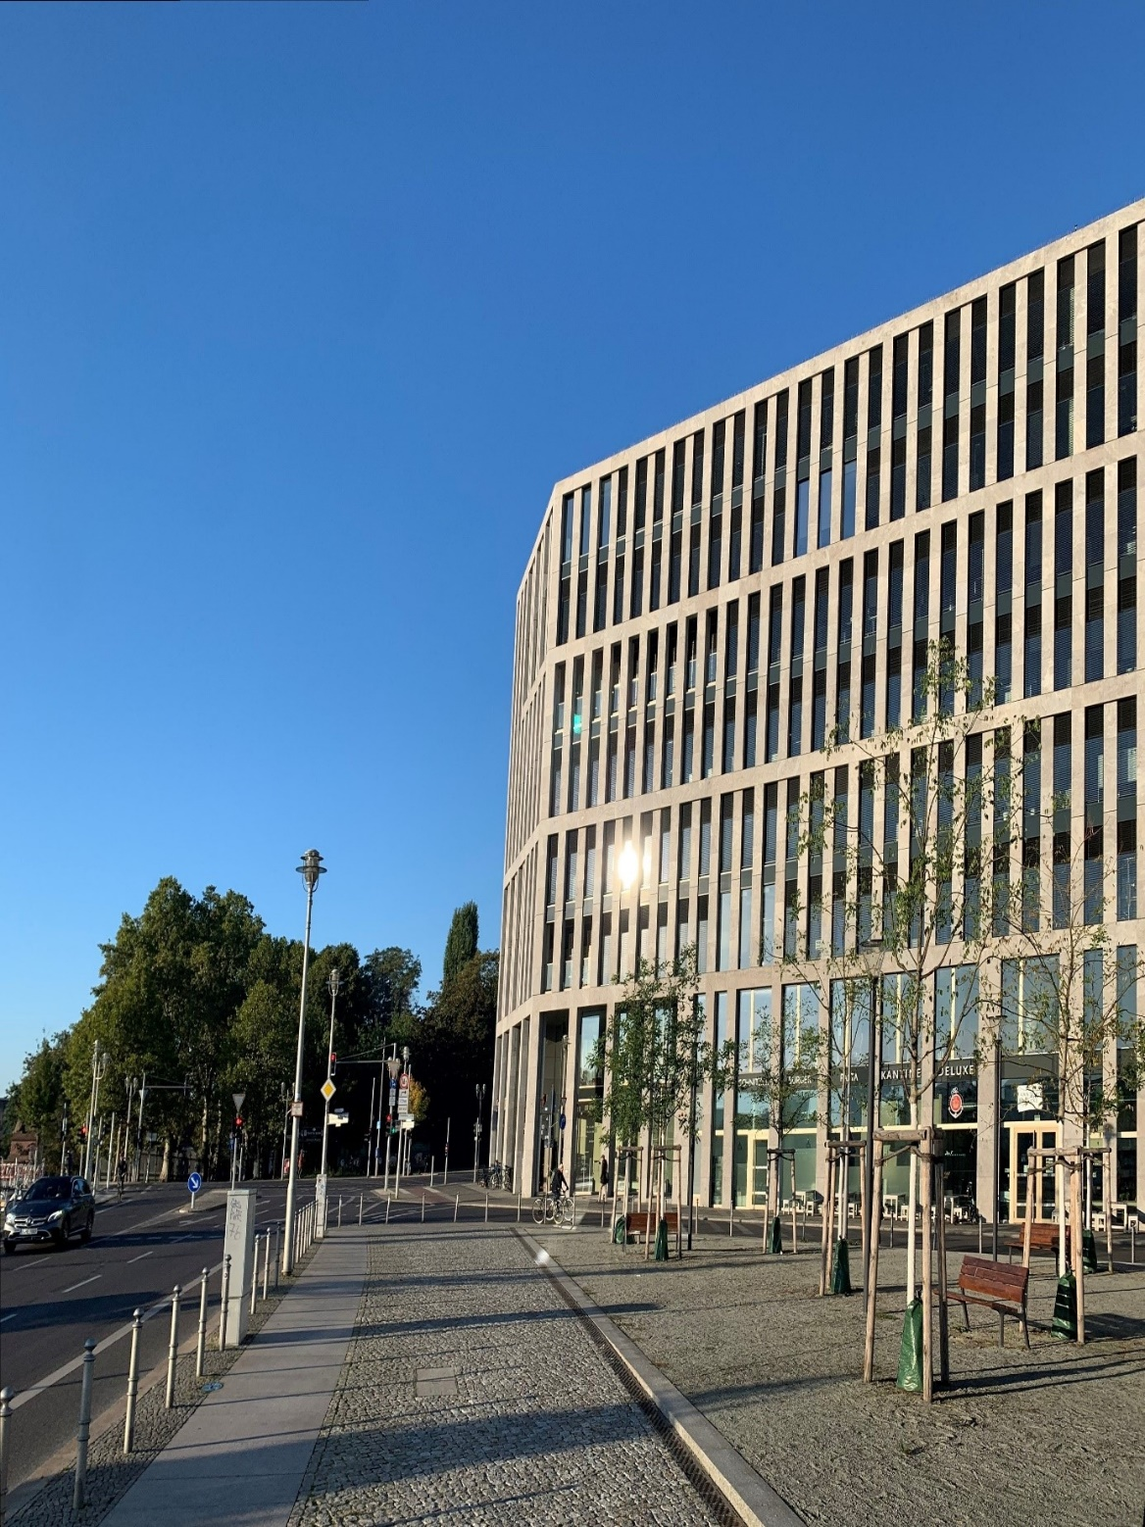
The new Method Park branch in Berlin at the Regus Center near the Federal Chancellory

