Press Release

Representatives of Erlangen municipality visit Method Park
Exchange of information among companies and municipal bodies
The Economic Department of Erlangen, the Local Advisory Council of Tennenlohe, and the resident companies meet at Method Park to exchange information and discuss economic topics related to Tennenlohe.
Erlangen, November 28, 2019 – The regular exchange of information between the municipal Economic Department, the Local Advisory Council of Tennenlohe, and the resident companies took place on Tuesday evening at the headquarters of the Method Park Group in Erlangen.
Konrad Beugel, Economic Consultant and Treasurer of the Erlangen municipality, moderated the meeting with over 40 participants and presented relevant news from the town hall. He also demonstrated progress on various topics and gave a review of the last event in October 2017.

Method Park presents its business areas
Prof. Dr. Bernd Hindel, CEO and Chairman of the Management Board of the Method Park Group, gave insights into the business areas of the company group specializing in the automotive and medical technology industry with consulting and support in software and systems engineering.

Traffic situation is deteriorating
Rolf Schowalter, chairman of the Local Advisory Council of Tennenlohe, reported on current topics dealt within the council and invited the participating company representatives to use the complaint procedure of the responsible authorities to call attention to the deteriorating traffic situation in the commercial district. This is the only way to emphasize a necessary change for Tennenlohe. The result of the subsequent discussion is that this deteriorating situation regarding traffic and parking is one of the companies’ greatest concerns as it jeopardized the further positive development of the commercial district in Tennenlohe.

Neighboring companies establish contacts
The meeting was rounded off by a social event with snacks and Franconian beer, where participants were able to exchange further information on local topics. Additionally, the event offered the chance to create new business opportunities with local companies.
Number of characters (space characters included): 2.141
About Method Park
Method Park specializes in complex product engineering in the environments of the automotive, medical and aerospace industries. Method Park’s portfolio includes consulting and engineering services, a comprehensive training program and the process management tool “Stages”.
Method Park was founded in 2001. On a worldwide basis, the company has supported and coached its customers on process optimization, compliance to industry-specific standards and legal regulations, as well as the management of projects, products and quality assurance. Method Park offers a practice-based training program on all current topics of Software & Systems Engineering. In 2017, Method Park became official VDA QMC training provider of Automotive SPICE® courses. For the recent version of Automotive SPICE® V3.1, Method Park has developed a free app for iOS and Android.
With “Stages”, Method Park offers a model-based process management tool, which supports its users on the definition, communication and application of complex processes, particularly in the engineering environment – globally, beyond organizational borders and always in compliance with various industry-specific standards.
With around 200 employees, the company group has locations in Erlangen, Frankfurt on the Main, Hamburg, Munich and Stuttgart as well as in Detroit, Miami and Pittsburgh in the US and Shanghai in China.
For further information please contact:
Dr. Christina Ohde-Benna, PR-Assistant
Method Park Holding AG, Wetterkreuz 19a, 91058 Erlangen, Germany
Christina.Ohde-Benna@methodpark.de www.methodpark.com
Available pictures:
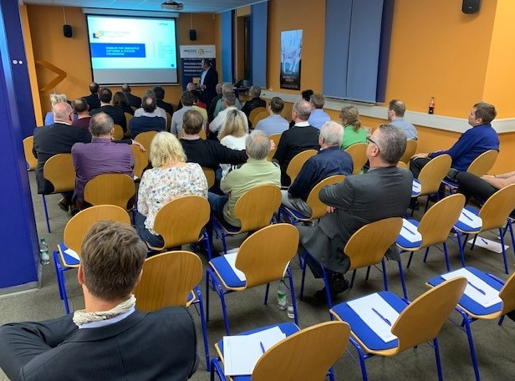
Representatives of the Economic Department of Erlangen, the Local Advisory Council of Tennenlohe, and the resident companies visit Method Park.

