Event Announcement

Process Insights Germany 2019
Method Park invites you to its annual Process Management Conference
On March 12, 2019, experts discuss current trends, solutions and best practices for the management of complex engineering processes.

Erlangen, February 6, 2019 – Method Park, the specialist for Software & Systems Engineering, invites you to Process Insights Germany 2019. This cross-industry specialist conference takes place on March 12, 2019 in Nuremberg and focuses on topics such as the complexity of modern engineering processes, solution approaches, strategies, as well as methods and tools for process management.

Success Factor Processes
Today, technology-oriented organizations transform their engineering and production processes faster and more radically than ever before. To develop innovative and future-oriented products, they have to comply with industry standards and apply modern development methods. Optimized processes are a key factor here, since organizations cannot master the complexity of projects, costs, time and quality without them.

Best Practices and “Stages” Roadmap
With presentations and experiential reports, Process Insights Germany demonstrates how the participants integrated improved processes as success factor in the product development of their organization. Participants will also receive insights into “Stages” – the tool which has been developed by Method Park, to manage complex engineering processes.

Consulting and Networking
In the so-called Consulting Café, participants can discuss their individual topics with Method Park experts and get informed in the accompanying exhibition. Breaks and an evening event offer the possibility for discussions and networking with the process experts.

Keynote and Information
This year, the keynote speaker of Process Insights Germany is Dr. Paul Nielsen, CEO of the Software Engineering Institute, Pittsburgh/US. The following website offers the agenda and further information:
https://www.methodpark.com/stages/process-insights-germany.html
Number of characters (space characters included): 1.954 characters
About Method Park
Method Park is specialist for complex product engineering in the environments of the automotive, medical and aerospace industries. Method Park’s portfolio includes consulting and engineering services, a comprehensive training program and the process management tool “Stages”.
Method Park was founded in 2001. On a worldwide basis, the company has coached its customers on process optimization, compliance to industry-specific standards and legal regulations. It has also consulted on the management of projects, products and quality assurance.
Method Park offers a practice-based training program on all current topics of Software & Systems Engineering. Method Park offers training at its locations in Germany and other European countries, the US and Asia.
With “Stages”, Method Park offers an individually customizable process management tool which supports its users on the definition, communication and application of complex processes.
With around 200 employees, the company group has locations in Erlangen, Frankfurt on the Main, Hamburg, Hanover, Munich and Stuttgart as well as in Detroit, Miami and Pittsburgh in the US.
For further information please contact:
Bernd Langer, Business Development
Method Park Software AG, Wetterkreuz 19a, 91058 Erlangen
Bernd.Langer@methodpark.de www.methodpark.de
Available pictures:
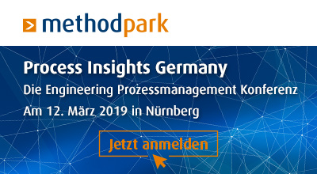
Banner of Process Insights 2019

