Press Release

VariantWorld.2017 was an outstanding success

Over 80 participants followed the invitation released by the German publisher Hanser and Method Park for the first VariantWorld in Leipzig last week. The two-day conference focused on current developments, challenges and solution approaches in variant management, for software and systems engineering.

Erlangen, May, 16, 2017 – On May 10 and 11, the first conference initiated by Method Park and the German publisher Carl Hanser Verlag – the VariantWorld.2017 – took place. This conference was established to deal with topics around variant and complexity management, in software and systems engineering. Prof. Ina Schäfer of the Technical University Braunschweig, took over the conference management.
Presentations, experience reports and discussions, focused on the management of variant diversity in software and systems development. Many companies are interested in experience exchange with colleagues from different domains, in particular searching for innovative and efficient solutions and appropriate tools. This was reflected by the accompanying exhibition at the Method Park booth, too. “Conference participants were particularly interested in specific solution approaches and process guidance for product line engineering by Stages”, says Dr. Sebastian Oster, who is Principal Consultant at Method Park and responsible for consulting on variant and complexity management.
At the end of the first conference day, the conference organizers invited participants for a walk through the historic center of Leipzig including a visit of the historical “Ratskeller”. This enabled attendees to exchange further experiences through informal networking.
Conference participants were from very different sectors such as automotive, aerospace, medical devices and IT suppliers. This made the premiere of the VariantWorld an outstanding success – it was the highest-grossing conference by Method Park. During the next few weeks, Method Park and Hanser Verlag, will start planning the VariantWorld.2018 in response to this year’s success.
Number of characters (spaces included): 2.076
About Method Park
For many years Method Park has successfully offered consulting in questions of software for safety-critical systems in the automotive industry and in the medical technology area, for which the company develops its own software solutions. Method Park brings extensive know-how to fields with high and extremely high safety requirements. With this knowledge Method Park offers its customers a variety of solutions from a single source that contribute to the success of each company. Method Park is the competent partner for consulting, coaching, training, engineering services and products for all questions of software development processes. The "Stages" Web-based process management portal developed by Method Park supports users with the practical implementation of development processes. Stages ensures the realization of predefined quality standards and process models and can be integrated in all common development environments. Furthermore, Stages enables the global distribution of development tasks beyond corporate boundaries. Founded in Erlangen in 2001, Method Park employs around 130 persons at sites in Erlangen, Munich and Stuttgart, as well as in Detroit and Miami in the USA.
For further information please contact:
Dr. Christina Ohde-Benna, PR-Assistant
Method Park Holding AG, Wetterkreuz 19a, 91058 Erlangen, Germany
Christina.Ohde-Benna@methodpark.de www.methodpark.de

Available pictures:
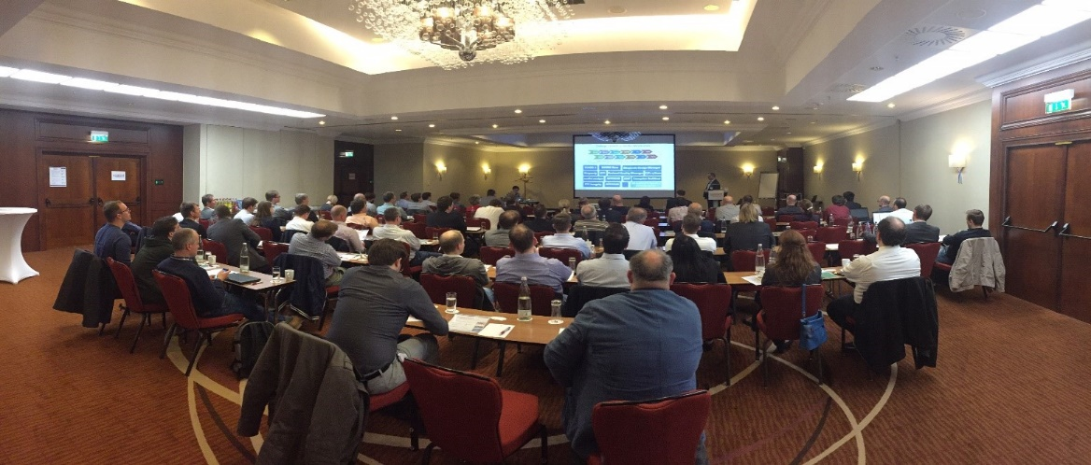
The VariantWorld.2017 was very exciting with expert presentations and experience reports.
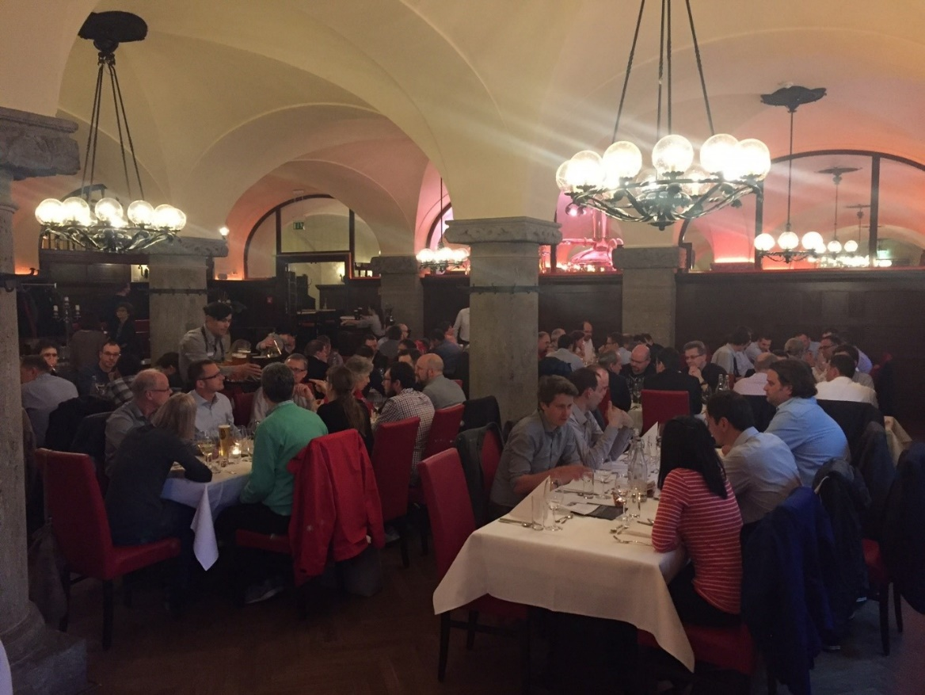
Conference participants of the VariantWorld.2017 were invited to the historical “Ratskeller” of Leipzig for the evening event.

