Press Release

Method Park among best three TOP JOB winners

Method Park belongs to the most attractive employers among medium-sized companies in Germany again. This is the result of an independent study conducted by the University of St. Gallen. The human resource management of the Erlangen-based IT company has been awarded with the certification “TOP employer” for the fourth time. The award was handed over to Method Park CEO Bernd Hindel by the former Federal Minister of Economics, Wolfgang Clement, on Friday in Berlin.

Erlangen, February 21st, 2017 – Method Park received this award in 2004, 2008, 2011 and 2017 and belongs to the most attractive medium-sized employers in Germany again. According to the study by TOP JOB, Method Park’s human resource management reached even third place among companies with up to 250 employees. In his speech during the award ceremony in the conference center of DZ Bank, Bank of Germany, on Friday in Berlin, the presenter Wolfgang Clement highlighted Method Park’s company culture and communication since Method Park had achieved outstanding results in this category.
Method Park CEO Bernd Hindel sees this quality certificate as verification for Method Park’s high quality in human resource management: “This certificate of TOP JOB is extremely important for medium-sized companies like Method Park. There are only few IT professionals and the competition among IT companies to win talents and smart minds is rough. That’s why we are particularly proud of receiving the TOP JOB certificate which demonstrates that we belong to the best.”
The company sees the reasons for its success in its open-minded company culture, its flat hierarchies and the willingness to steadily improve with focus on further training of employees on a personal and professional basis. “We demand the willingness of life-long learning from our employees and we support them on this learning process and offer them individual opportunities”, says Bernd Hindel. Method Park established an internal qualification program for young professionals in which expertise and skills, far beyond their studies, are transferred to graduates. The company itself permanently develops, too. “Every year, we focus on another company principle during internal project work”, says Bernd Hindel.
Method Park executives also focus on the work-life-balance of their employees. The company offers a trust-based working hour scheme and regularly organizes common sports and leisure activities.
About 150 employees are contributing to the company’s success. In 2016, the Method Park group generated a turnover of about 14.7 million euros with its three locations in Germany and its two locations in the US. Method Park will set up further locations in Germany this year.
Together with the University of St. Gallen, TOP JOB started to conduct studies in employer quality and human resource management of medium-sized companies in Germany according to their size in 2002. These studies are focused on six categories: “Management & Vision”, “Motivation & Dynamics”, “Culture & Communication”, “Employee Development & Prospects”, “Family-friendly Working & Demography” and “Internal Entrepreneurship”. Conducting an employee survey and auditing the human resource department are part of these studies.
This year, the jury again consists of public characters such as Donata Apelt-Ihling, General Manager of Alfred Apelt GmbH, Tim Zimmermann, partner of the company consulting group Roland Berger, Bert Rürup, initiator of the German “Rürup-Rente” and Chairman of the Board of Trustees of the German Institute for Economic Research, Walter Jochmann, General Manager of Kienbaum Consultants International and Dieter Hundt, President of the Federation of German Employers’ Associations from 1996 to 2013. The German Minister of Economics Wolfgang Clement has been mentor of TOP JOB since 2005.

Number of characters (spaces included): 3.860
About Method Park
For many years Method Park has successfully offered consulting in questions of software for safety-critical systems in the automotive industry and in the medical technology area, for which the company develops its own software solutions. Method Park brings extensive know-how to fields with high and extremely high safety requirements. With this knowledge Method Park offers its customers a variety of solutions from a single source that contribute to the success of each company. Method Park is the competent partner for consulting, coaching, training, engineering services and products for all questions of software development processes. The "Stages" Web-based process management portal developed by Method Park supports users with the practical implementation of development processes. Stages ensures the realization of predefined quality standards and process models and can be integrated in all common development environments. Furthermore, Stages enables the global distribution of development tasks beyond corporate boundaries. Founded in Erlangen in 2001, Method Park employs around 150 persons at sites in Erlangen, Munich, Stuttgart and Hannover, as well as in Detroit and Miami in the USA.
For further information please contact:
Dr. Christina Ohde-Benna, PR-Assistant
Method Park Holding AG, Wetterkreuz 19a, 91058 Erlangen, Germany
Christina.Ohde-Benna@methodpark.de www.methodpark.de
Available pictures:
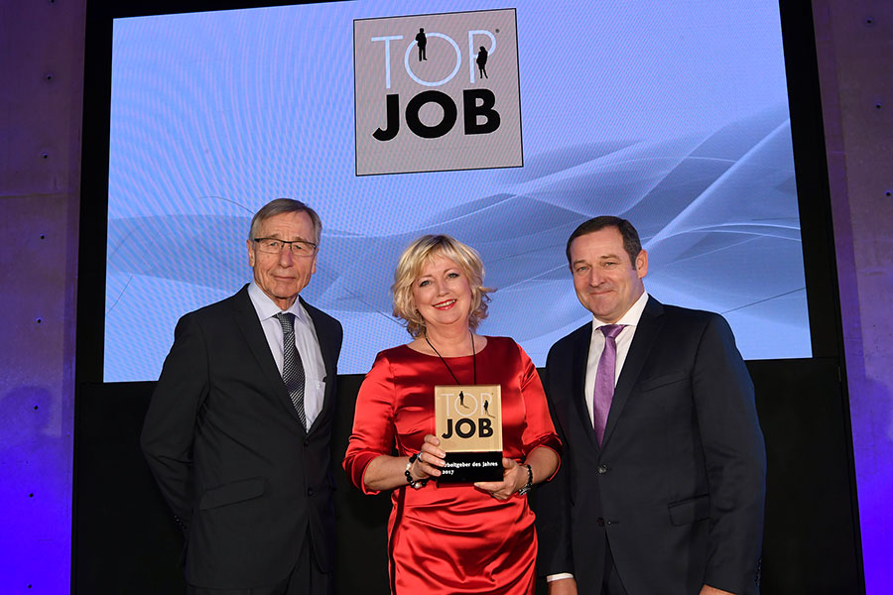
From the left: Wolfgang Clement, Beatrice Hindel (CEO Assistant), Bernd Hindel (CEO Method Park)

