Press Release

Stages Insights 2016: Method Park conference, including separate workshop day

The software company based in Erlangen demonstrated how to implement and maintain meaningful processes in five steps, with its so-called ‘Stages Method’.

Erlangen, 21st March 2016 – Almost 100 participants joined the Method Park Stages Insights conference on 17th March in Fürth to learn how to establish effective and meaningful processes in product development. This year, Method Park hosted its conference with presentations, user reports and discussions focusing on methods and tools for successful process management. This is Method Park’s tenth annual event.
Method Park supplies its process management tool ‘Stages’ and will release the latest Stages version [V7] in the course of 2016. Method Park CTO Erich Meier exclusively presented the new features of Stages V7 at the conference to the very absorbed audience.
Method Park experts offered individual consulting on solution approaches, for customer-specific challenges during the breaks in proceedings using the Consulting Café, which was fully booked by participants. Throughout the Stages Insights conference, participants had the opportunity to network with other participants and exchange information and experience at the booths of the Method Park partners, IBM and Pedco.
It became clear that having the right tool is no guarantee for reasonable processes but meaningful methodical approaches in implementing those tools is crucial.
All conference participants had the exclusive opportunity to join the “Process Management 4.0 Workshop” on 18th March, focusing on the so-called ‘Stages Method’. This is based on the five steps towards sector-independent implementation and realization of process management.
Executives of companies from different industries such as BSH, BRP, Continental Automotive, ESCRYPT, ETAS, Evosoft, Hilti, Hella, Schaeffler Technologies, ZF Friedrichshafen and Siemens Healthcare, joined this year’s Stages Insights conference.
“The varied content of presentations gave a good insight into the use of Stages and demonstrated how different customers apply the advantages of Stages. The presentation of the new Stages V7 features was extremely interesting”, the Solutions Data and Project Manager at Continental Automotive, Michaela Daxl, said.
Method Park will host its next Stages Insights conference, in spring 2017. “The throughout positive and constructive feedback by our participants, confirms our conviction that methodical process management is extremely important for many companies”, said CTO Erich Meier.
Number of characters (spaces included): 2.575
About Method Park
For many years Method Park has successfully offered consulting in questions of software for safety-critical systems in the automotive industry and in the medical technology area, for which the company develops its own software solutions. Method Park brings extensive know-how to fields with high and extremely high safety requirements. With this knowledge Method Park offers its customers a variety of solutions from a single source that contribute to the success of each company. Method Park is the competent partner for consulting, coaching, training, engineering services and products for all questions of software development processes. The "Stages" Web-based process management portal developed by Method Park supports users with the practical implementation of development processes. Stages ensures the realization of predefined quality standards and process models and can be integrated in all common development environments. Furthermore, Stages enables the global distribution of development tasks beyond corporate boundaries. Founded in Erlangen in 2001, Method Park employs around 125 persons at sites in Erlangen, Munich and Stuttgart, as well as in Detroit and Miami in the USA.
For further information please contact:
Dr. Christina Ohde-Benna, PR-Assistant
Method Park Holding AG, Wetterkreuz 19a, 91058 Erlangen, Germany
Christina.Ohde-Benna@methodpark.de www.methodpark.de
Available pictures:
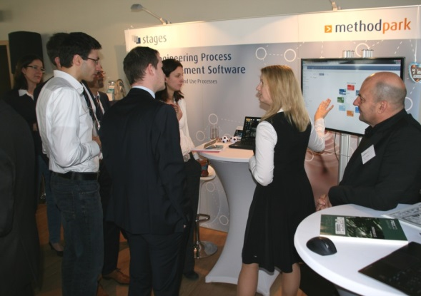
The participants of Stages Insights 2016 had the opportunity to gather information about the new features of Stages V7 at the Method Park booth.

