Press Release

Method Park supports promotion of young

Together with the department for computer science of the University of Erlangen-Nuremberg and the society for the promotion of engineering studies “Förderkreis Ingenieurstudium” Method Park contributes to a robot which should introduce school classes to science and technologies at the Museum for Industrial Culture in Nuremberg.

Erlangen, 24th September 2015 - Method Park is financing a humanoid robot which will be in the focus of the exhibition “Technikland – staunen @ lernen” hosted by the Museum for Industrial Culture in Nuremberg. The robot called NAO has now been handed over by Method Park CEO Dr. Martin Geier and Dr. Christian Götz of the department for computer science of the University of Erlangen-Nuremberg to Prof. Dr. Wilhelm Schwieger and Telka Klein of the society for the promotion of engineering studies “Förderkreis Ingenieurstudium”.
“We help introducing pupils to science and technologies and support the promotion of engineering for talented pupils which is important for our company”, says Martin Geier.
“There is an urgent need for engineers and technical professionals on the job market. We are happy to support the promotion of talented pupils for these jobs together with Method Park”, Wilhelm Schwieger explains.
“The course for computer science offers good training for interested graduates”, Christian Götz of the department for computer science of the University of Erlangen-Nuremberg adds.
NAO is a humanoid robot built by the French manufacturer Aldebaran Robotics. It is 57.3 cm high and weighs 5.2 kg. A 1.6 GHz Intel ATOM Z530 processor and two HD cameras which take 30 pictures per second are integrated in his head. His human-like body and ability to interact reduce reservations towards robots.
Again Martin Geier: “NAO embodies computer science which can be touched. Pupils and students can learn how to program with him. NAO is a valuable completion since we apply technologies of the industry sector 4.0 at Method Park.”
The learning laboratory “Technikland – staunen @ lernen” is hosted by the Museum for Industrial Culture in Nuremberg for the third time. About 30 experiments enable pupils to learn intuitively by trying, explain technical and scientific contexts and where those contexts can be found in our daily lives. The topics of this year’s exhibition are power and construction, energy, light and colors as well as computers and robotics.
The society for the promotion of engineering studies, “Förderkreis Ingenieurstudium”, started getting young pupils interested for technologies, science and particularly engineering in 1998. Pupils can get interested for this topic already during their school time by participating in practical projects, competitions, internships and workshops.

Interesting Links
Förderkreis Ingenieurstudium e.V.: http://www.fking.de/
Roboterhersteller Aldebaran: https://www.aldebaran.com/en/humanoid-robot/nao-robot
Museum Industriekultur, Lernlabor Technikland: https://museen.nuernberg.de/museum-industriekultur/kalender-details/technikland-2015-920/

Number of characters (spaces included): 2.772

About Method Park
For many years Method Park has successfully offered consulting in questions of software for safety-critical systems in the automotive industry and in the medical technology area, for which the company develops its own software solutions. Method Park brings extensive know-how to fields with high and extremely high safety requirements. With this knowledge Method Park offers its customers a variety of solutions from a single source that contribute to the success of each company. Method Park is the competent partner for consulting, coaching, training, engineering services and products for all questions of software development processes. The "Stages" Web-based process management portal developed by Method Park supports users with the practical implementation of development processes. Stages ensures the realization of predefined quality standards and process models and can be integrated in all common development environments. Furthermore, Stages enables the global distribution of development tasks beyond corporate boundaries. Founded in Erlangen in 2001, Method Park employs around 125 persons at sites in Erlangen, Munich and Stuttgart, as well as in Detroit and Miami in the USA.
For further information please contact:
Philipp Donnert, Marketing
Method Park Holding AG, Wetterkreuz 19a, 91058 Erlangen, Germany
Tel. +49 9131 97206-285, Fax +49 9131 97206-280
Philipp.Donnert@methodpark.de www.methodpark.de

Available Pictures:
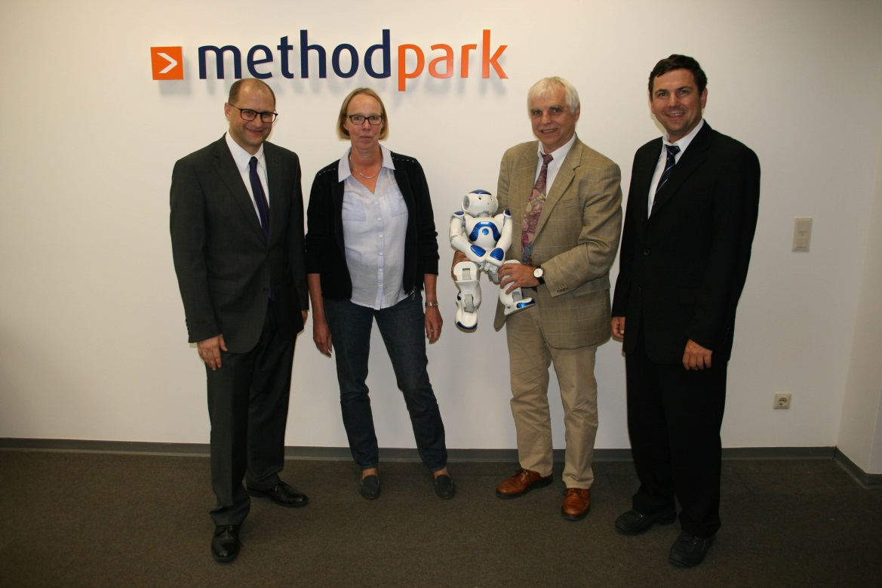
Method Park CEO Dr. Martin Geier (left) and Dr. Christian Götz, head of the service center at the department of computer science at the University of Erlangen-Nürnberg (right), hand over the NAO to Prof. Dr. Wilhelm Schwieger and Telka Klein, Förderkreis Ingenieurstudium e.V.

