Press Release

Method Park launches a new Stages version to the market
Version 7.2 of the the process management tool Stages is now available
Method Park has recently presented the new version of its process management software Stages V7.2. In the last year, Method Park completely overhauled the tool’s user interface. Now, important features like the standard compliance, process tailoring and the creation of reports are integrated.
Erlangen, October 10, 2018 – Stages V7.2 offers a completely new user experience for the creation, management, and application of complex engineering processes. The modernized user interface, based on the newest web technology, now includes further important features. This makes the application of this tool for complex projects in software and systems engineering even more attractive.
With the compliance feature, process modelers can now ensure compliance to industry-specific standards such as Automotive SPICE®, ISO 26262, CMMI and many more, throughout the processes. The process evaluation for existing standard requirements has been eased and is now performed faster.
In Stages V7.2, the adjustment of processes to project-specific conditions has been redesigned and streamlined; the tailoring assistant more efficiently supports the user during the adjustment of the standard process to fit individual requirements in specific projects.
Additionally, the creation and update of reports are now integrated. In V7.2, project-specific data is rapidly available in a structured format for the users, with which they can automatically generate key performance indicators (KPIs) for process application, compliance or tailoring. So now they continuously improve processes.
Dr. Erich Meier, CTO and Chief Architect of Stages, emphasizes: “Stages V7.2 even more focuses on the execution of processes in specific projects. The new features cover the entire life cycle of a process: from the definition over publication, to the application in the development of products ready for series production.”
Please find more information about Stages, its features and benefits on the Method Park website: https://www.methodpark.com/stages.html
Number of characters (space characters included): 2.015
About Method Park
Method Park is specialist for innovative software and systems engineering in the safety-critical environments of the medical and automotive industries. Method Park’s portfolio includes consulting and engineering services, a comprehensive training program and the process management tool “Stages”.
Method Park was founded in 2001. On a worldwide basis, the company has coached its customers on process optimization, compliance to industry-specific standards and legal regulations. It has also consulted on the management of projects, products and quality assurance.
Method Park offers a practice-based training program on all current topics of software and systems engineering. Method Park offers training at its locations in Germany and other European countries, the US and Asia.
With “Stages”, Method Park offers an individually customizable process management tool which supports its users on the definition, communication and application of complex processes.
The company group has locations in Erlangen, Frankfurt on the Main, Hannover, Munich and Stuttgart as well as in Detroit, Miami and Pittsburgh in the US. With around 170 employees, Method Park generated an operative turnover of about 16 million euros in 2017.

For further information please contact:
Bernd Langer, Business Development
Method Park Software AG, Wetterkreuz 19a, 91058 Erlangen, Germany
Bernd.Langer@methodpark.de www.methodpark.com

Available Pictutres:

Stages Logo

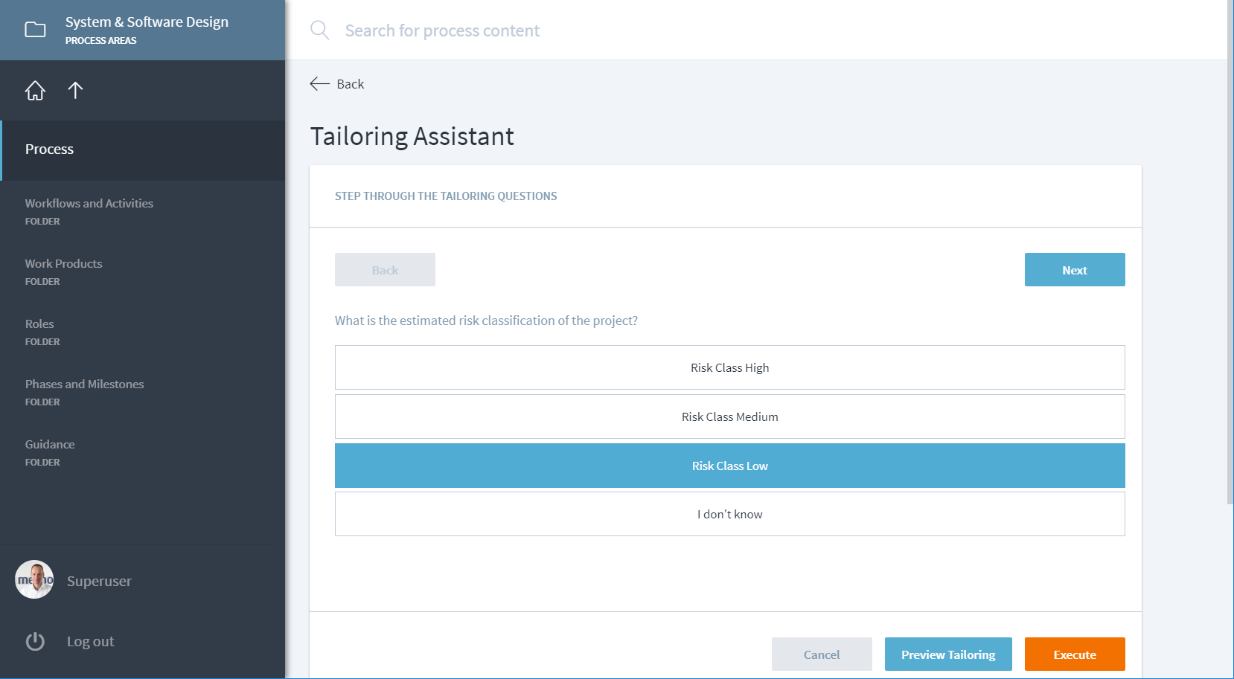
Stages Tailoring-Assistent in V7.2

