Press Release

Heiko Zastrau leads new ASQF Automotive Professional Group Berlin/Brandenburg
The German Association for Software Quality and Further Education, ASQF e.V., initiated a new Automotive Professional Group in Berlin to promote and discuss topics of the sector very close to political events.
Erlangen, February 28, 2018 – Political framework conditions and industry specific standards are the two key factors influencing the automotive industry. To fulfill these influencing factors, the German Association for Software Quality and Further Education (ASQF e.V.) initiated an Automotive Professional Group in Berlin/Brandenburg, too. Heiko Zastrau from Method Park is the head of this professional group. Together with supporters and speakers, he will take care of education, information exchange and cooperation in this professional group.
The first public meeting of this new professional group will take place on March 20, starting at 6 p.m. at TEMIC Automotive Electric Motors. Erhardt Wunderlich of Bombardier Transportation will give a presentation on the topic “Testing in 2020 – How to test software in the automotive industry in future?”.
The professional groups are the centerpiece of ASQF; professional group meetings and the ASQF Days are informational and discussion panels for current topics and innovative concepts. Participants directly benefit from knowledge and experience of other experts. Throughout Germany, the professional groups deal with topics such as development processes, process models, globalization and international standards.
Heiko Zastrau has many years of experience in software and systems engineering. As Principal Consultant, he supports Method Park customers in the automotive industry, particularly on process improvement projects.
Number of characters (spaces included): 1.762
About ASQF e.V.
For over 20 years, the German Association for Software Quality and Further Education (ASQF e.V.) has supported development and assurance of software and systems quality. Also it has promoted internationally consistent training and further education of (IT) professionals. As a network, the ASQF connects a wide group, from efficient start-ups, medium-sized companies, global players, universities and research institutes and develops proposals, which take account of the new requirements of digitalization. 1,400 members from Germany, Austria and Switzerland, exchange information on relevant topics from the software industry in the ASQF. Experts and decision makers of this special-field software quality and connected subject areas, are members of the ASQF professional groups. They support compliance to quality standards, promote, discuss and develop current and future topics in this complex industry. The association supports its members with regional and national professional groups and the ASQF Days meetings. ASQF is partner of the International Software Quality Institute (iSQI) which globally certifies (IT) experts.
About Method Park
Method Park is specialist for innovative software and systems engineering in the safety-critical environments of the medical and automotive industries. Method Park’s portfolio includes consulting and engineering services, a comprehensive training program and the process management tool “Stages”. Method Park was founded in 2001. On a worldwide basis, the company has coached its customers on process optimization, compliance to industry-specific standards and legal regulations. It has also consulted on the management of projects, products and quality assurance. Method Park offers a practice-based training program on all current topics of software and systems engineering. Method Park offers training at its locations in Germany and other European countries, the US and Asia. With “Stages”, Method Park offers an individually customizable process management tool which supports its users on the definition, communication and application of complex processes. The company group has locations in Erlangen, Frankfurt on the Main, Hannover, Munich and Stuttgart as well as in Detroit, Miami and Pittsburgh in the US. With around 170 employees, Method Park generated an operative turnover of about 16 million euros in 2017.

For further information please contact:
Dr. Christina Ohde-Benna, PR-Assistant
Method Park Holding AG, Wetterkreuz 19a, 91058 Erlangen, Germany
Christina.Ohde-Benna@methodpark.de www.methodpark.com

Available pictures:
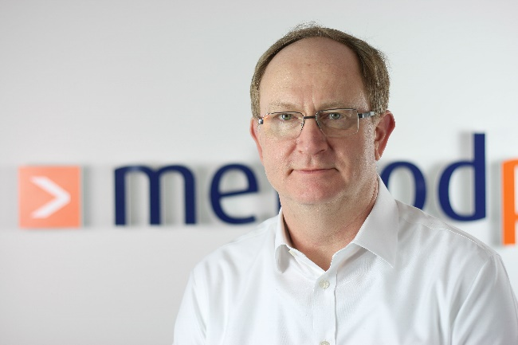
Heiko Zastau, Principal Consultant at Method Park and head of ASQF Professional Group Automotive Berlin/Brandenburg

