Press Release

VariantWorld.2018

Software developers and decision makers meet for the second time to discuss variant management and complexity in software and systems engineering. The German publisher Carl Hanser Verlag and the consulting company Method Park invite all interested parties to join this event in Leipzig on April 17 and 18.

Erlangen, December, 20, 2018 – “Same same but different” – this motto applies to every successful manufacturer in each individual industry. Each of them offers a great variety of individual products which differ only in detail from each other and are often developed in parallel. Effective variant management enables systematic and efficient re-use of product elements. After its successful start this year, the second VariantWorld conference in Leipzig in April 2018 presents how to manage variant diversity and product complexity and how to master related challenges and problems.
Prof. Dr. Ina Schaefer from the Institute for Software Engineering and Automotive IT of the Technical University Braunschweig again organizes the practice-oriented experts conference for software developers and decision makers in cooperation with technical magazines such as HANSER automotive, HANSER Konstruktion, :K automation and OBJECTspektrum.
The conference focuses on the following topics:
- Processes and methods for the management of variant diversity and product complexity
- Best practices and roll-out strategies in systems development
- Solutions from different industries and inspirations of current research
Additionally to presentations by experts, the conference provides interactive sessions such as the solutions trail. “In this session, we discuss present questions and problems. At different stopovers, we present and discuss potential solutions”, says the conference organizer, Sylvia Hahn, of the German publisher Hanser Verlag. On the first conference day, conference participants have the opportunity to hand in their own questions and topics in the Open Space which are then bundled by the advisory board. On the second conference day, participants can discuss individual topics and questions among each other in thematic groups.
Participants can look forward to a high-quality conference program. Companies such as Continental, EIGNER Engineering Consult, Fraunhofer IESE, FZI Research Center for Information Technology, IBM, INVENSITY GmbH, Method Park Consulting GmbH, Method Park Engineering GmbH, Robert Bosch GmbH, SICK AG, Soley GmbH, University of Gothenburg, and voelter – engineering office for software technology already confirmed their presentations at this conference.
Participant comments on VariantWorld.2017:
“Qualified participants, high-level presentations.” Dr. Ulrich Schweiger, Knorr-Bremse Rail Vehicle Systems, Germany
“A great platform for presentations and discussions around one of the biggest challenges in product development.” Florian Bruckner, Daimler Buses – EvoBus GmbH
“The conference provides a thematic overview and the opportunity for networking.” Volker That, Siemens Healthcare GmbH
Please find further information and the conference agenda here: www.variantworld.de
Number of characters (space characters included): 3.126
About Method Park
Method Park is an established and successful consulting and software company for safety-critical systems in the automotive industry and medical technology area, for which the company develops advanced proprietary software solutions. Method Park brings extensive know-how to fields which have high and extremely high safety requirements. With this knowledge Method Park offers its customers a range of solutions that contributes to the success of each company. Method Park is the competent partner for consulting, coaching, training, engineering services and products for all software development processes. The "Stages" Web-based process management portal, developed by Method Park, supports users with the practical implementation of all development processes. Stages ensures the implementation of predefined quality standards and process models and can be integrated in all common development environments. Furthermore, “Stages” enables the global distribution of development tasks beyond corporate boundaries. Founded in Erlangen in 2001, Method Park employs around 170 persons at sites in Erlangen, Munich, Stuttgart, Hannover, and Frankfurt as well as in Detroit, Miami, and Pittsburgh in the USA.
For further information please contact:
Dr. Christina Ohde-Benna, PR-Assistant
Method Park Holding AG, Wetterkreuz 19a, 91058 Erlangen, Germany
Christina.Ohde-Benna@methodpark.de www.methodpark.com

Available pictures:
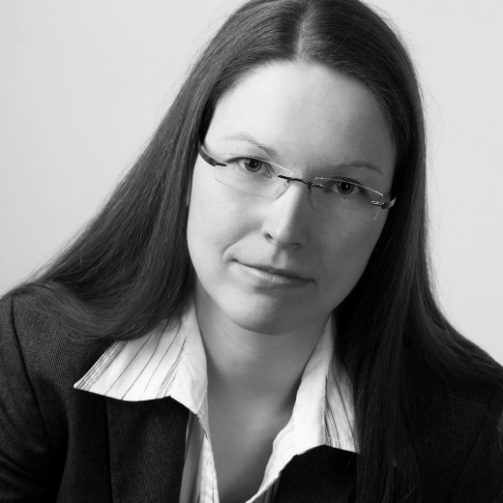
Organizer of VariantWorld: Prof. Dr. Ina Schaefer of the Institute for Software Engineering and Automotive IT of the Technical University Braunschweig © Prof. Dr. Ina Schaefer

