Press Release

Method Park wins German Design Award 2017

For its current recruiting campaign, Method Park wins the German Design Award 2017 in the category “Integrated Campaigns and Advertising”.

Erlangen, 27th October 2016 – For its recruiting campaign “Do what you love”, Method Park wins the German Design Award 2017 in the category “Integrated Campaigns and Advertising”. This campaign by Method Park pursued the goal of increasing the awareness of being an attractive employer among students at different universities in Bavaria. In cooperation with the design specialists of comdeluxe, an agency for strategic design in Nuremberg, Method Park developed means of communication such as live events, landing pages, flyers, adverts and posters for targeted addressing of computer sciences students. With this campaign, Method Park won the award with a jury consisting of 40 members.
The German Design Award is an exclusive international prize awarded by the German Design Council. Its goal is finding new design trends, present and award them. High-quality product and communications design work, setting trends in international design, is annually awarded with the German Design Award (founded in 2012). It is one of the most recognized design competitions worldwide and is held in high esteem not only among experts.
“We are very proud that Method Park received this award and that the jury chose our campaign from over 4,000 international submitted applications. We were honored as a “special mention” for a specifically successful campaign. This shows that our company understood the challenges of addressing a new employee generation and is able to reach out to our future colleagues with target-oriented perspectives,” says Prof. Dr. Bernd Hindel, CEO of Method Park company group.
Number of characters (spaces included): 1.770
About Method Park
For many years Method Park has successfully offered consulting in questions of software for safety-critical systems in the automotive industry and in the medical technology area, for which the company develops its own software solutions. Method Park brings extensive know-how to fields with high and extremely high safety requirements. With this knowledge Method Park offers its customers a variety of solutions from a single source that contribute to the success of each company. Method Park is the competent partner for consulting, coaching, training, engineering services and products for all questions of software development processes. The "Stages" Web-based process management portal developed by Method Park supports users with the practical implementation of development processes. Stages ensures the realization of predefined quality standards and process models and can be integrated in all common development environments. Furthermore, Stages enables the global distribution of development tasks beyond corporate boundaries. Founded in Erlangen in 2001, Method Park employs around 130 persons at sites in Erlangen, Munich and Stuttgart, as well as in Detroit and Miami in the USA.
For further information please contact:
Dr. Christina Ohde-Benna, PR-Assistant
Method Park Holding AG, Wetterkreuz 19a, 91058 Erlangen, Germany
Christina.Ohde-Benna@methodpark.de www.methodpark.de

Available pictures:

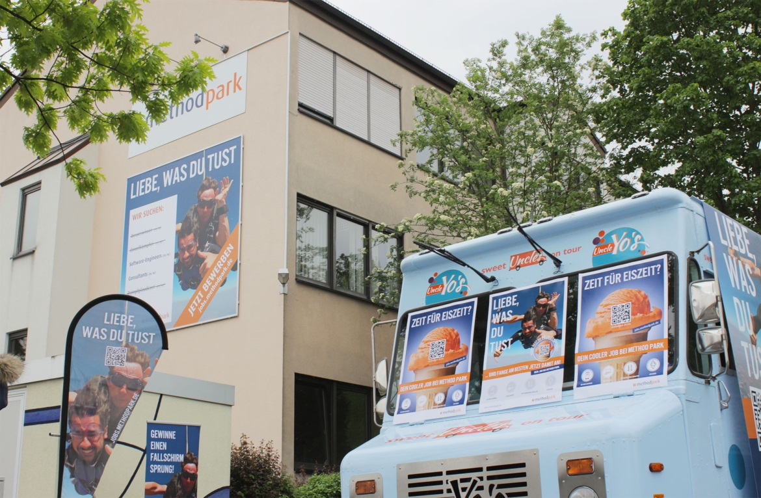
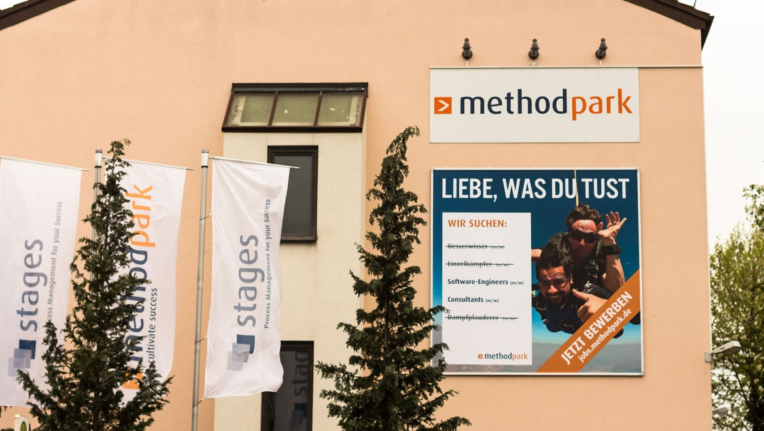
Method Park’s campaign “Do what you love”
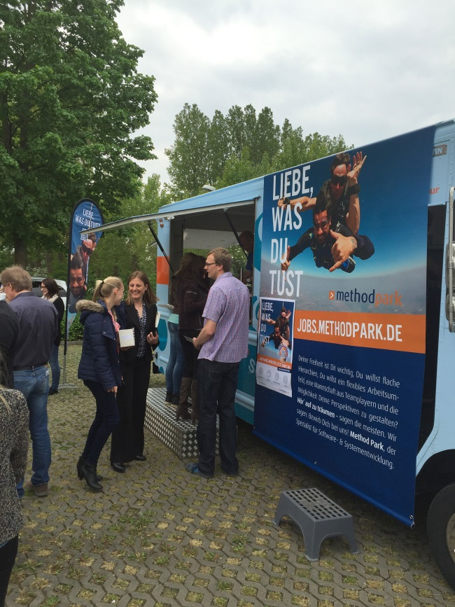
In early summer 2016, students in Erlangen and Nuremberg got a frozen yogurt for free at this ice truck and found out more about Method Park as an attractive employer.

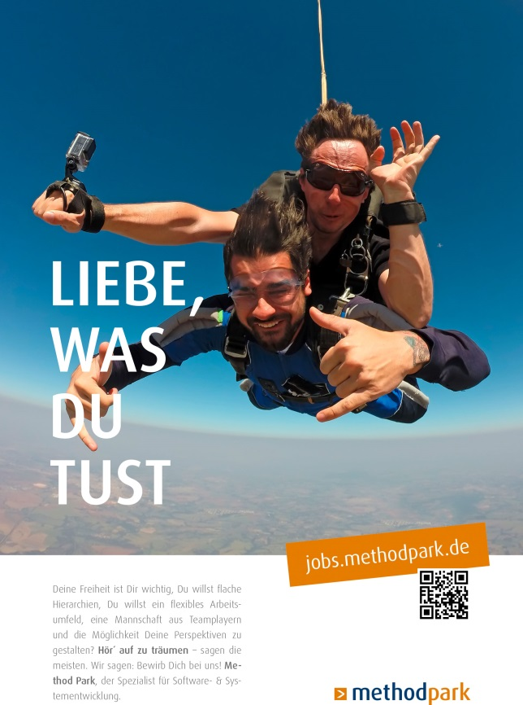
Method Park’s Human Resources poster
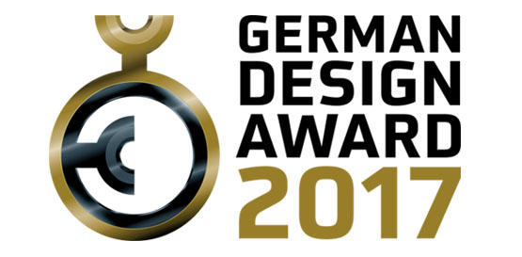
Logo of the German Design Award 2017

