Press Release / March 31, 2015

Method Park receives the IBM Partner Award again

As part of InterConnect 2015, the world's largest IBM partner convention, Method Park was awarded the "Innovation in Continuous Engineering Award" for the second time in a row.

More than 21,000 participants – IBM customers, business partners and IBM experts – attended the InterConnect convention in Las Vegas at the end of February. As a result of organizational restructuring, IBM introduced its newly created divisions for the first time at the five-day convention. In the future, Method Park will be a partner of the "Internet of Things" Division and will help IBM customers define the engineering processes that they need to make the "Internet of Things" possible.
Method Park received its award once again for the benefits that the "Stages" process management portal, an in-house development of Method Park, provides to the users of IBM products through its integration with the "Rational Team Concert" tool. "We are very proud of this prestigious award and are delighted with the recognition that IBM has once again expressed for our innovative 'Stages' product," said Method Park CEO Prof. Bernd Hindel enthusiastically.
Stefano Bensi, responsible for European sales of the "Internet of Things" Division at IBM, said: “IBM has long understood that our customers value the strength of our partner ecosystem. Through integrations and collaboration, we strive for excellence in thought leadership, offer compelling solutions, and share deep industry expertise. This award recognizes those who have delivered tremendous value to our clients through our successful partnership.”
The integration of Stages with Rational Team Concert (RTC) connects the process management of stages with the application lifecycle management potential of RTC. Together, Stages and RTC ensure efficient compliance with industry standards and best practice procedures, such as CMMI, Automotive SPICE®, ISO 26262, IEC 62304 or DO-178/254. Both tools create an environment that allows engineering processes to be defined, communicated and used throughout the entire product development cycle, thus helping them to successfully meet the complex requirements of modern engineering.
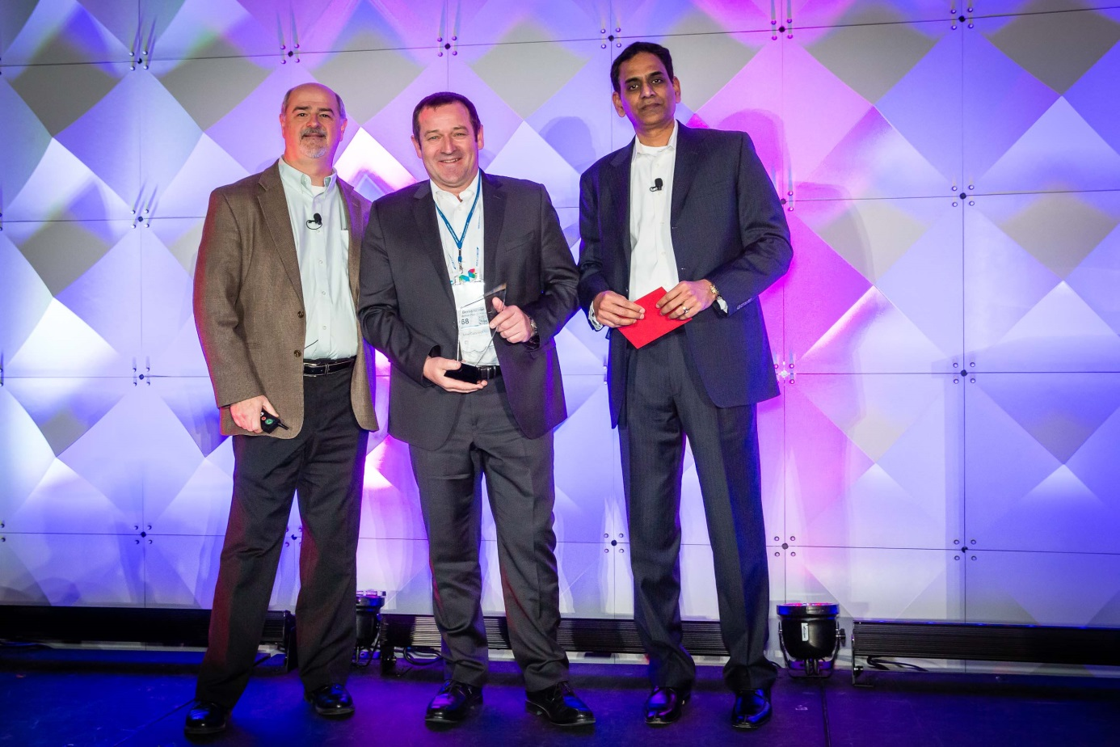
Image: Method Park CEO Prof. Bernd Hindel is very pleased about being awarded the IBM Partner Award.

About Method Park
For many years Method Park has successfully offered consulting in questions of software for safety-critical systems in the automotive industry and in the medical technology area, for which the company develops its own software solutions. Method Park brings extensive know-how to fields with high and extremely high safety requirements. With this knowledge Method Park offers its customers a variety of solutions from a single source that contribute to the success of each company.
Method Park is the competent partner for consulting, coaching, training, engineering services and products for all questions of software development processes. The "Stages" Web-based process management portal developed by Method Park supports users with the practical implementation of development processes. Stages ensures the realization of predefined quality standards and process models and can be integrated in all common development environments. Furthermore, Stages enables the global distribution of development tasks beyond corporate boundaries.
Founded in Erlangen in 2001, Method Park employs around 125 persons at sites in Erlangen, Munich and Stuttgart, as well as in Detroit and Miami in the USA.

For further information please contact:
Philipp Donnert, Marketing
Method Park Holding AG, Wetterkreuz 19a, 91058 Erlangen, Germany
Tel. +49 9131 97206-285, Fax +49 9131 97206-280
Philipp.Donnert@methodpark.de www.methodpark.de

